Fig3b

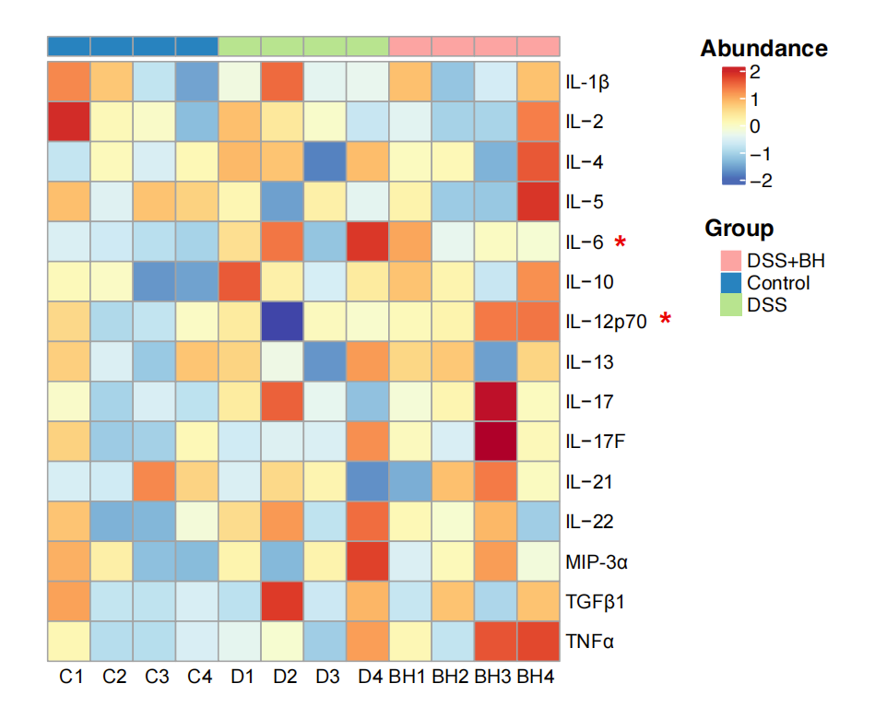

表格：metabolism_factor.csv

使用软件：R

使用代码：

library(ComplexHeatmap)

library(grid)

factor<-read.csv("metabolism_factor.csv",header=T,row.names=1)

factor<-log10(factor)

factor<-as.matrix(factor)

groupcolor<-c("#1F79B4","#B2DF8A","#33A02C")

names(groupcolor)<-c("C","D","BH")

ann_colors<-list(group=groupcolor)

ann_colors=list(group=c(C="#1F79B4",D="#B2DF8A",BH="#33A02C"))

annotation_col=data.frame(group=c(rep("C",4),rep("D",4),rep("BH",4)))

p3<-pheatmap(factor, scale="row", col=colorRampPalette(rev(brewer.pal(n = 11, name = "RdYlBu")))(20),annotation_col=annotation_col,annotation_names_col=F,cluster_cols=FALSE,cluster_rows=FALSE,annotation_colors=ann_colors)

Fig 6a-f

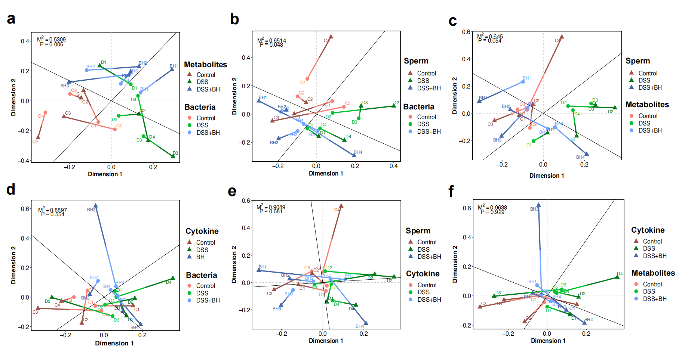

表格：mantel_facor+metabolites+sperm.xlsx

mantel_bacteria.xlsx

使用软件：R

绘图平台：<https://www.omicstudio.cn/tool>

Fig 6g-h

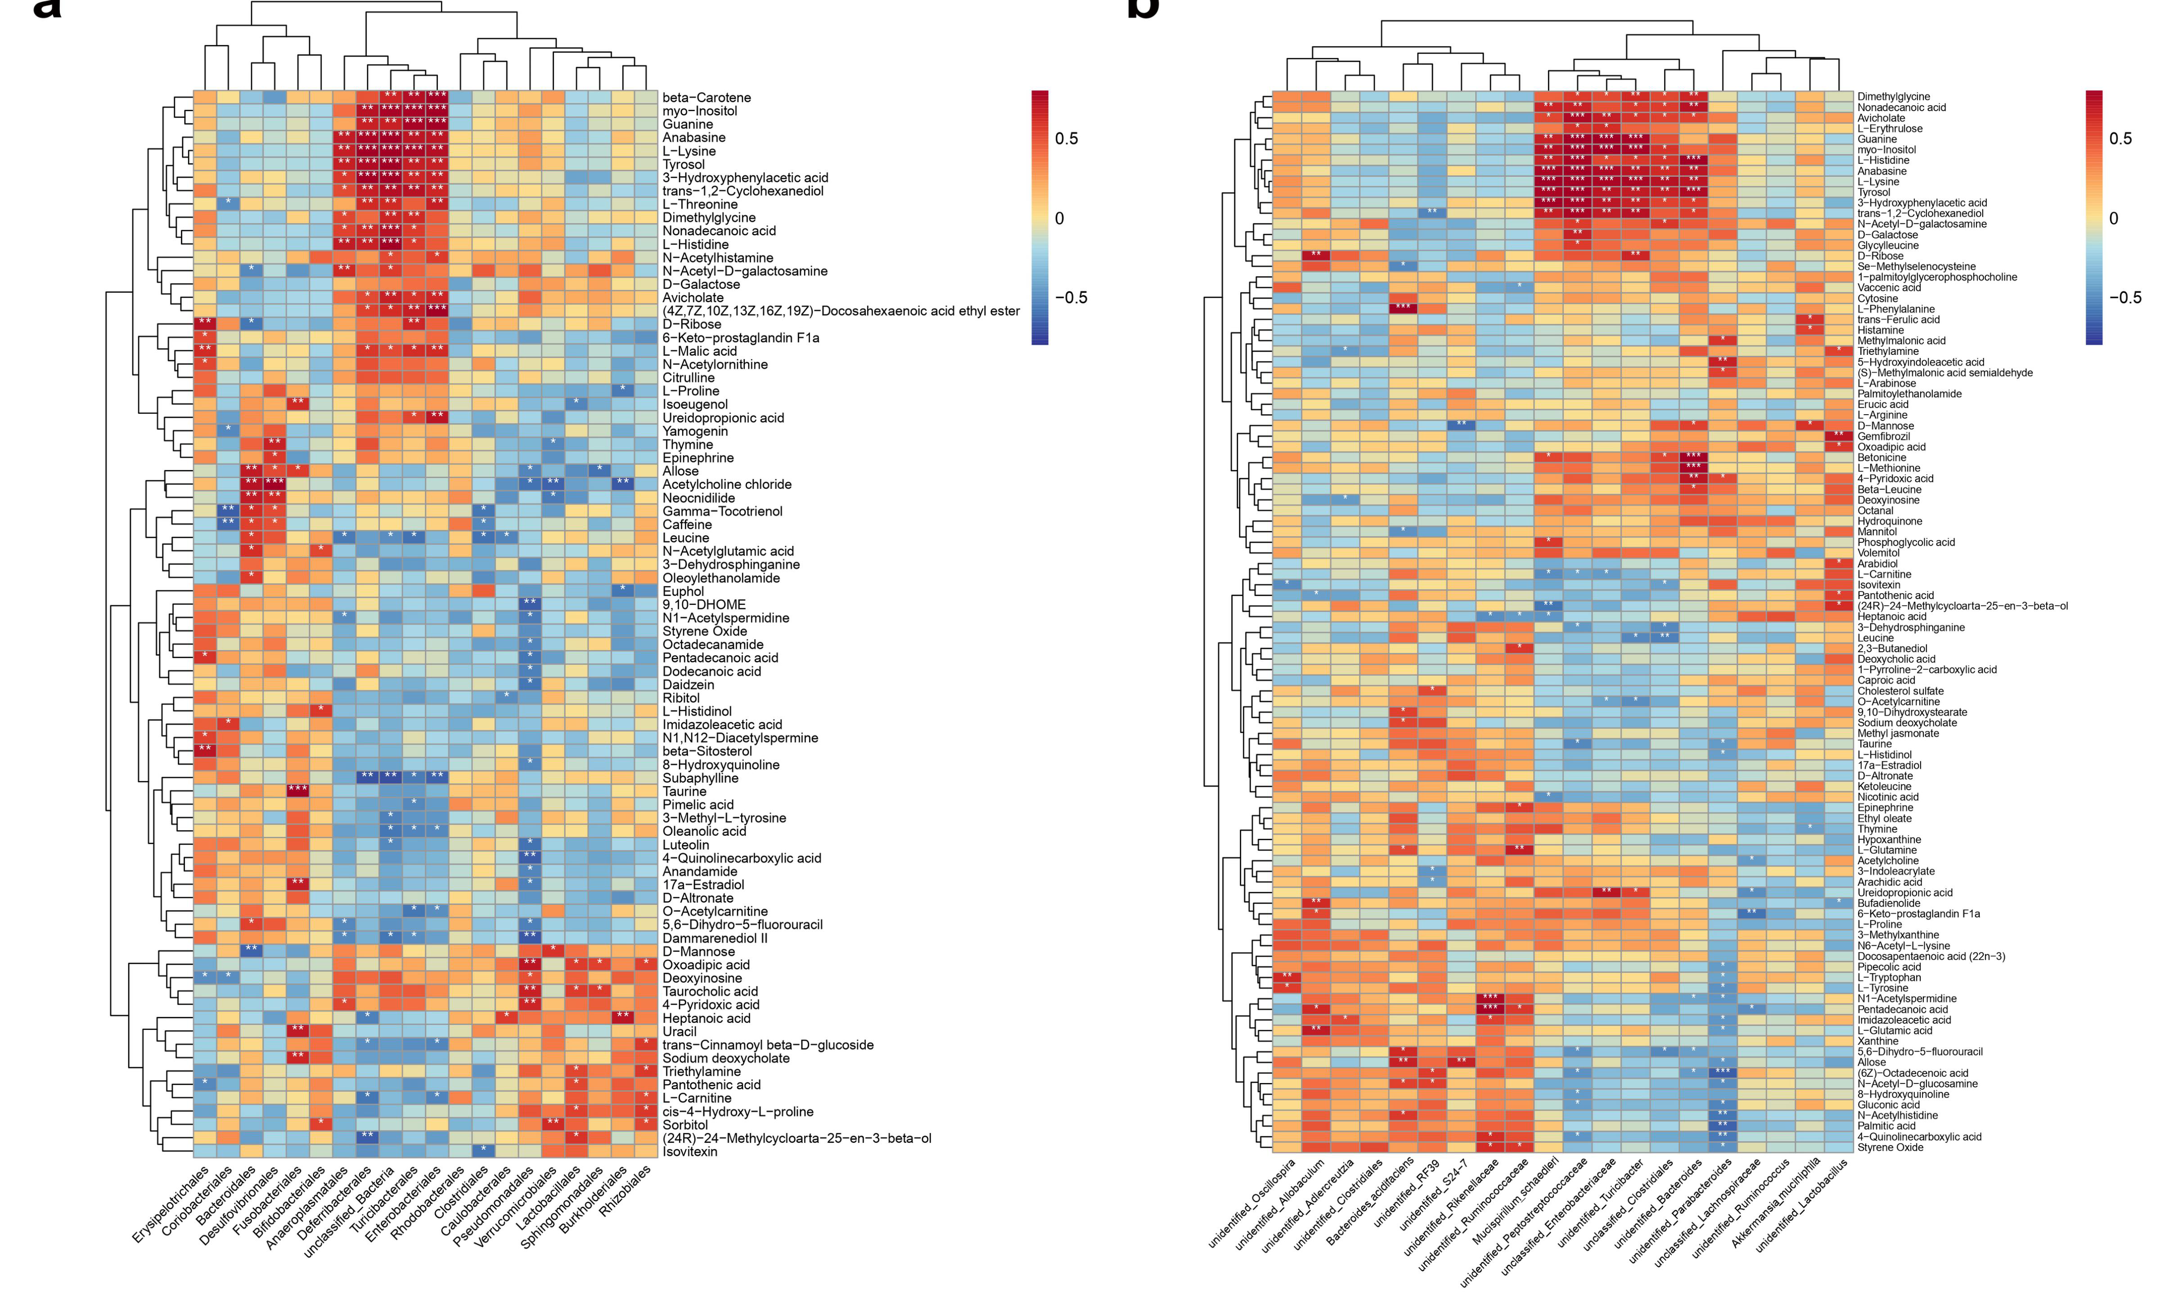

表格：cor_metabolism.xlsx

cor_species.xlsx

cor_order.xlsx

使用软件：R

绘图平台：<https://www.omicstudio.cn/tool>

Fig 6i-k

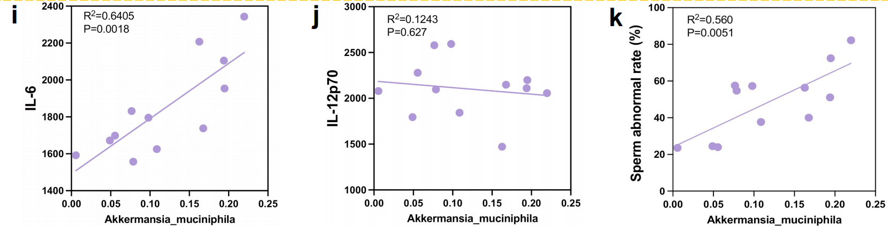

表格：correlation.xlsx

使用软件：graphpad prism9